Project Design Phase-II
Data Flow Diagram & User Stories

Date | 3 October 2026
Team ID | SWTID-2026-3373
Project Name | Import Data using Transform Maps (Spreadsheet)
Maximum Marks | 4 Marks

Data Flow Diagrams:
A Data Flow Diagram (DFD) is a traditional visual representation of the information flows within a system. A neat and clear DFD can depict the right amount of the system requirement graphically. It shows how data enters and leaves the system, what changes the information, and where data is stored.
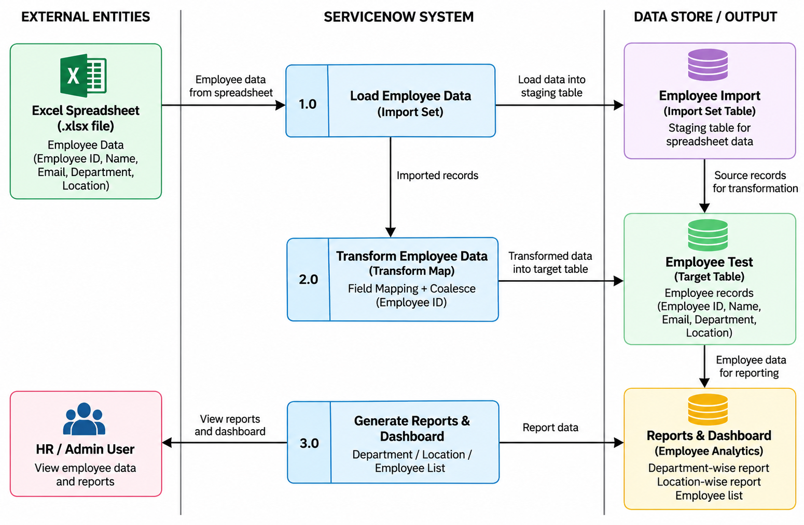

User Stories

User Type | Functional Requirement (Epic) | Story No. | User Story / Task | Acceptance Criteria | Priority | Release
HR/Admin User | Employee Data Management | USN-1 | As an HR/Admin user, I can create and manage the Employee Test table to store employee information. | Employee Test table contains Employee ID, Employee Name, Email, Department and Location. | High | Sprint-1
HR/Admin User | Employee Data Import | USN-2 | As an HR/Admin user, I can load employee data from an Excel spreadsheet into the Employee Import staging table. | Spreadsheet records are successfully loaded into Employee Import. | High | Sprint-1
HR/Admin User | Data Transformation | USN-3 | As an HR/Admin user, I can create and use the Sample Spreadsheet Import Transform Map. | Source fields are mapped to the corresponding Employee Test fields. | High | Sprint-1
HR/Admin User | Data Transformation | USN-4 | As an HR/Admin user, I can transform imported employee records into the Employee Test table. | Imported records are successfully transformed into Employee Test. | High | Sprint-1
HR/Admin User | Duplicate Prevention | USN-5 | As an HR/Admin user, I can use Employee ID as a Coalesce field to prevent duplicate records. | Existing employee records are updated instead of creating duplicates. | High | Sprint-2
HR/Admin User | Data Validation | USN-6 | As an HR/Admin user, I can verify the results of an import through Transform History. | Transform History shows the import result and record status. | Medium | Sprint-2
HR/Admin User | Reporting | USN-7 | As an HR/Admin user, I can generate employee reports based on department and location. | Department and location reports display the employee data correctly. | Medium | Sprint-2
HR/Admin User | Dashboard | USN-8 | As an HR/Admin user, I can view employee information through an analytics dashboard. | Employee reports are available on the Employee Analytics Dashboard. | Medium | Sprint-2

